Game Design Document

Fill up the Following document

1. Write the title of your project.

Diamond run

1. What is the goal of the game?

Collect as much diamonds without being caught and reach the finish line.

1. Write a brief story of your game?

You are a most wanted thief who robs and collects diamonds . One day while stealing a police finds you, But don’t let him catch you . Run to the van while collecting diamonds to complete a level

1. Which are the playing characters of this game?

* Playing characters are the ones which respond to the user based on the input from the user
* Cars, monkeys, dinos, wizards etc, are the playing characters in the game.

|  |  |  |
| --- | --- | --- |
| Number | Character Name | What can this character do? |
| 1 | thief | Pc/can collect gold |
| 2 |  |  |
| 3 |  |  |
| 4 |  |  |
| 5 |  |  |
| 6 |  |  |
| 7 |  |  |
| 8 |  |  |

1. Which are the Non Playing Characters of this game?

* Non Playing characters are the ones which don't have an action or a behaviour when the user interacts with the game.
* Hurdles, stones, bananas, coins, etc are non playing characters in the game.

|  |  |  |
| --- | --- | --- |
| Number | Character Name | What can this character do? |
| 1 | police | Npc/try to catch the thief |
| 2 | coins | Npc |
| 3 | hurdles | npc |
| 4 | Black van |  |
| 5 |  |  |
| 6 |  |  |
| 7 |  |  |
| 8 |  |  |

Draw your imagination of this game. What does this game look like?

* Draw the game either on your computer or on paper,
* Add images of scenes of the game to show each of the playing and non-playing characters at least once.

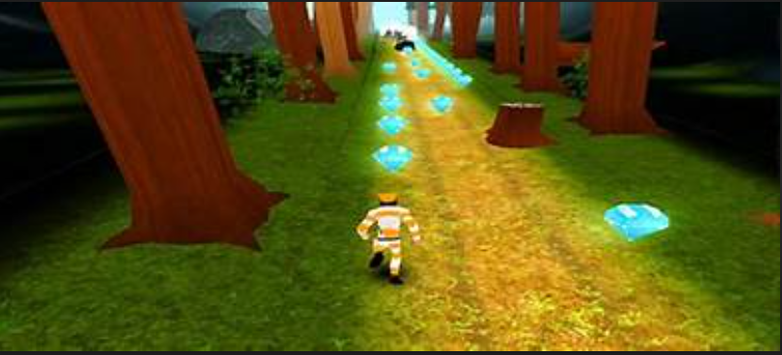

How do you plan to make your game engaging?

It has levels that completed when you reach the black van.